Coronavirus disease 2019 (COVID-19)
Situation Report – 40

Data as reported by 10AM CET 29 February 2020

HIGHLIGHTS

- Two new Member States (Mexico and San Marino) reported cases of COVID- 19 in the past 24 hours.

- WHO has published the Rational use of personal protective equipment for COVID-19. This document summarizes WHO recommendations for the appropriate use of personal protective equipment (PPE) in health care and community settings, including the handling of cargo. More information on Infection Prevention and Control (IPC) activities can be found in the Subject in Focus.
SITUATION IN NUMBERS
total and new cases in last 24 hours

Globally
85 403 confirmed (1753 new)

China
79 394 confirmed (435 new)
2838 deaths (47 new)

Outside of China
6009 confirmed (1318 new)
53 countries (2 new)
86 deaths (19 new)

WHO RISK ASSESSMENT

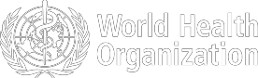
China | Very High
Regional Level | Very High
Global Level | Very High

Figure 1. Countries, territories or areas with reported confirmed cases of COVID-19, 29 February 2020

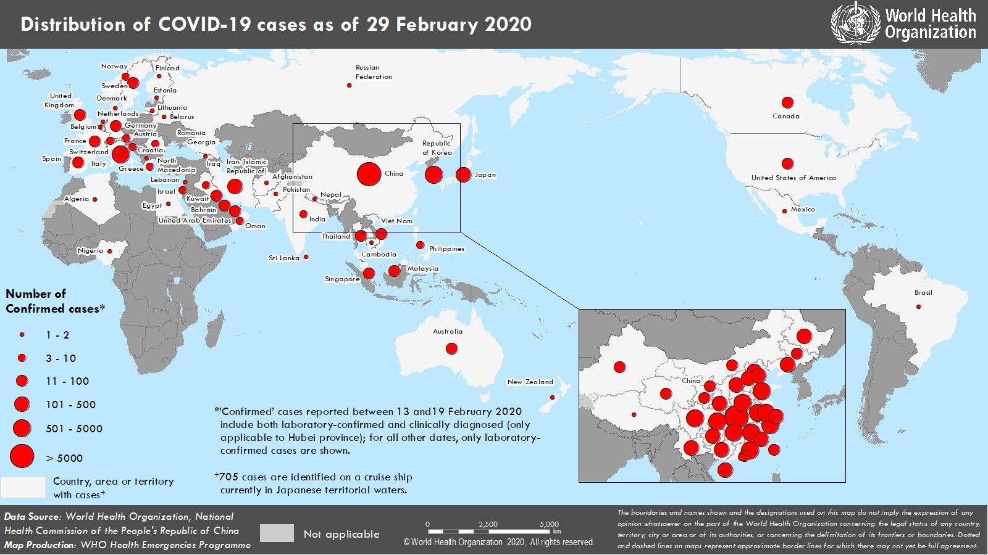

SUBJECT IN FOCUS: UPDATE ON INFECTION PREVENTION AND CONTROL

Infection prevention and control (IPC) is a major factor in preventive and mitigation measures for COVID-19. To ensure evidence-based quality guidance and prompt response to global demand for personal protective equipment (PPE), WHO has convened the IPC expert global network of specialists from around the world since the beginning of the outbreak. Experts are members of the Global Infection Prevention and Control Network (GIPCN) or members of relevant institutions caring for COVID-19 patients. This network discusses technical aspects of IPC measures, and shares epidemiological updates and experiences across affected countries. In consultation with this global IPC expert network, WHO has released three key IPC interim guidance materials.

Updates on IPC activities include the following:
- Publishing the guidance document: Rational use of personal protective equipment for COVID-19. This document summarizes WHO recommendations for the appropriate use of PPE in health care and community settings, including the handling of cargo.

- Deployment of IPC specialists to Italy to support the COVID-19 response and to facilitate IPC training in the European region.

- Development of Frequently Asked Questions (FAQ) in response to queries from the public and communities on blood safety, PPE for specimen collection, cleaning & disinfection, self-isolation and self-monitoring.

- Launching the OpenWHO online course “Infection Prevention and Control (IPC) for COVID-19” on 25 February. The course has been accessed by 15,391 users as of 28 February (see Figure 1).

Figure 1: The top 10 countries that have accessed the online course: “Infection Prevention and Control (IPC) for COVID- 19” as of 27 February. Source: openWHO.org

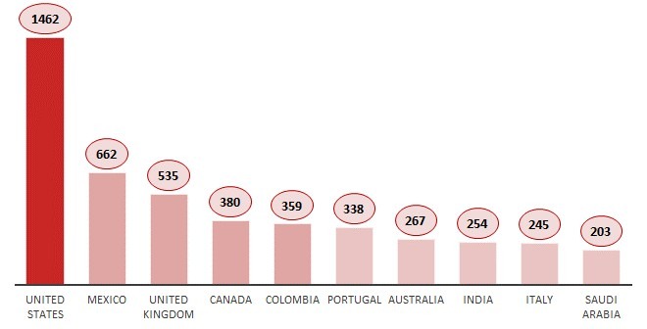
SURVEILLANCE

Table 1. Confirmed and suspected cases of COVID-19 acute respiratory disease reported by provinces, regions and cities in China, Data as of 29 February 2020
Province/ Region/ | Population (10,000s) | Confirmed | Daily Suspected |  | Cumulative  Confirmed Deaths
City | cases |  | cases | Deaths | cases
Hubei | 5917 | 423 | 159 | 45 | 66337 |  | 2727
Guangdong | 11346 | 1 | 0 | 0 | 1349 |  | 7
Henan | 9605 | 0 | 0 | 1 | 1272 |  | 21
Zhejiang | 5737 | 0 | 0 | 0 | 1205 |  | 1
Hunan | 6899 | 1 | 1 | 0 | 1018 |  | 4
Anhui | 6324 | 0 | 0 | 0 | 990 |  | 6
Jiangxi | 4648 | 0 | 1 | 0 | 935 |  | 1
Shandong | 10047 | 0 | 0 | 0 | 756 |  | 6
Jiangsu | 8051 | 0 | 0 | 0 | 631 |  | 0
Chongqing | 3102 | 0 | 7 | 0 | 576 |  | 6
Sichuan | 8341 | 0 | 2 | 0 | 538 |  | 3
Heilongjiang | 3773 | 0 | 0 | 0 | 480 |  | 13
Beijing | 2154 | 1 | 9 | 1 | 411 |  | 8
Shanghai | 2424 | 0 | 28 | 0 | 337 |  | 3
Hebei | 7556 | 0 | 0 | 0 | 318 |  | 6
Fujian | 3941 | 0 | 0 | 0 | 296 |  | 1
Guangxi | 4926 | 0 | 0 | 0 | 252 |  | 2
Shaanxi | 3864 | 0 | 0 | 0 | 245 |  | 1
Yunnan | 4830 | 0 | 3 | 0 | 174 |  | 2
Hainan | 934 | 0 | 5 | 0 | 168 |  | 5
Guizhou | 3600 | 0 | 1 | 0 | 146 |  | 2
Tianjin | 1560 | 0 | 14 | 0 | 136 |  | 3
Shanxi | 3718 | 0 | 0 | 0 | 133 |  | 0
Liaoning | 4359 | 0 | 15 | 0 | 121 |  | 1
Hong Kong SAR | 745 | 1 | 0 | 0 | 94 |  | 2
Jilin | 2704 | 0 | 3 | 0 | 93 |  | 1
Gansu | 2637 | 0 | 0 | 0 | 91 |  | 2
Xinjiang | 2487 | 0 | 0 | 0 | 76 |  | 3
Inner Mongolia | 2534 | 0 | 0 | 0 | 75 |  | 0
Ningxia | 688 | 1 | 0 | 0 | 73 |  | 0
Taipei and environs | 2359 | 7 | 0 | 0 | 39 |  | 1
Qinghai | 603 | 0 | 0 | 0 | 18 |  | 0
Macao SAR | 66 | 0 | 0 | 0 | 10 |  | 0
Xizang | 344 | 0 | 0 | 0 | 1 |  | 0
Total | 142823 | 435 | 248 | 47 | 79394 |  | 2838

Table 2. Countries, territories or areas outside China with reported laboratory-confirmed COVID-19 cases and deaths. Data as of 29 February 2020
Country | Total confirmed* cases (new) | Total deaths (new) | Transmission classification† | Days since last reported case
Western Pacific Region
Republic of Korea | 3150 (813) | 17 (4) | Local transmission | 0
Japan | 230 (20) | 5 (1) | Local transmission | 0
Singapore | 98 (2) | 0 (0) | Local transmission | 0
Australia | 24 (1) | 0 (0) | Local transmission | 0
Malaysia | 24 (0) | 0 (0) | Local transmission | 1
Viet Nam | 16 (0) | 0 (0) | Local transmission | 16
Philippines | 3 (0) | 1 (0) | Imported cases only | 25
Cambodia | 1 (0) | 0 (0) | Imported cases only | 33
New Zealand | 1 (0) | 0 (0) | Imported cases only | 1
European Region
Italy | 888 (238) | 21 (4) | Local transmission | 0
Germany | 57 (31) | 0 (0) | Local transmission | 0
France | 57 (19) | 2 (0) | Local transmission | 0
Spain | 32 (7) | 0 (0) | Local transmission | 0
The United Kingdom | 20 (4) | 0 (0) | Local transmission | 0
Sweden | 12 (5) | 0 (0) | Imported cases only | 0
Switzerland | 10 (4) | 0 (0) | Imported cases only | 0
Norway | 6 (2) | 0 (0) | Imported cases only | 0
Croatia | 5 (2) | 0 (0) | Local transmission | 0
Israel | 5 (2) | 0 (0) | Imported cases only | 0
Austria | 5 (1) | 0 (0) | Imported cases only | 0
Romania | 3 (2) | 0 (0) | Imported cases only | 0
Greece | 3 (0) | 0 (0) | Imported cases only | 1
Denmark | 2 (1) | 0 (0) | Imported cases only | 0
Georgia | 2 (1) | 0 (0) | Imported cases only | 0
Netherlands | 2 (1) | 0 (0) | Imported cases only | 0
Finland | 2 (0) | 0 (0) | Imported cases only | 3
Russian Federation | 2 (0) | 0 (0) | Imported cases only | 29
San Marino | 1 (1) | 0 (0) | Local transmission | 0
North Macedonia | 1 (0) | 0 (0) | Imported cases only | 3
Estonia | 1 (0) | 0 (0) | Imported cases only | 2
Lithuania | 1 (0) | 0 (0) | Imported cases only | 1
Belarus | 1 (0) | 0 (0) | Imported cases only | 1
Belgium | 1 (0) | 0 (0) | Imported cases only | 25
South-East Asia Region
Thailand | 42 (2) | 0 (0) | Local transmission | 0
India | 3 (0) | 0 (0) | Imported cases only | 26
Nepal | 1 (0) | 0 (0) | Imported cases only | 47
Sri Lanka | 1 (0) | 0 (0) | Imported cases only | 33
Eastern Mediterranean Region
Iran (Islamic Republic of) | 388 (143) | 34 (8) | Local transmission | 0
Kuwait | 45 (2) | 0 (0) | Imported cases only | 0
Bahrain | 38 (5) | 0 (0) | Imported cases only | 0
United Arab Emirates | 19 (0) | 0 (0) | Local transmission | 1
Iraq | 8 (1) | 0 (0) | Imported cases only | 0
Oman | 6 (0) | 0 (0) | Imported cases only | 1
Lebanon | 2 (0) | 0 (0) | Imported cases only | 3
Pakistan | 2 (0) | 0 (0) | Imported cases only | 3

Afghanistan | 1 (0) | 0 (0) | Imported cases only | 5
Egypt | 1 (0) | 0 (0) | Imported cases only | 15
Region of the Americas
United States of America | 62 (3) | 0 (0) | Local transmission | 0
Canada | 14 (3) | 0 (0) | Imported cases only | 0
Mexico | 2 (2) | 0 (0) | Imported cases only | 0
Brazil | 1 (0) | 0 (0) | Imported cases only | 3
African Region
Algeria | 1 (0) | 0 (0) | Imported cases only | 4
Nigeria | 1 (0) | 0 (0) | Imported cases only | 1
Subtotal for all regions | 5304 (1318) | 80 (17)
International conveyance (Diamond Princess) ‡ | 705 (0) | 6 (2) | Local transmission | 3
Grand total§ | 6009 (1318) | 86 (19)
*Case classifications are based on WHO case definitions for COVID-19.
†Transmission classification is based on WHO analysis of available official data and may be subject to reclassification as additional data become available. Countries/territories/areas experiencing multiple types of transmission are classified in the highest category for which there is evidence; they may be removed from a given category if interruption of transmission can be demonstrated. It should be noted that even within categories, different countries/territories/areas may have differing degrees of transmission as indicated by the differing numbers of cases and other factors. Not all locations within a given country/territory/area are equally affected.
Terms:
- Community transmission is evidenced by the inability to relate confirmed cases through chains of transmission for a large number of cases, or by increasing positive tests through routine screening of sentinel samples.
- Local transmission indicates locations where the source of infection is within the reporting location.
- Imported cases only indicates locations where all cases have been acquired outside the location of reporting.
- Under investigation indicates locations where type of transmission has not been determined for any cases.
- Interrupted transmission indicates locations where interruption of transmission has been demonstrated (details to be determined)
‡Cases identified on a cruise ship currently in Japanese territorial waters.
§266 female/386 male/5357 unknown. 28 healthcare workers (5 female/12 male/ 11 unknown)
Corrigendum: Values under ‘Days since last reported case’ have been updated to reflect time of reporting within a given day

Figure 2. Epidemic curve of confirmed COVID-19 cases (n=5173) reported outside of China, by date of report and WHO region with complete days of reporting through 28 February 2020

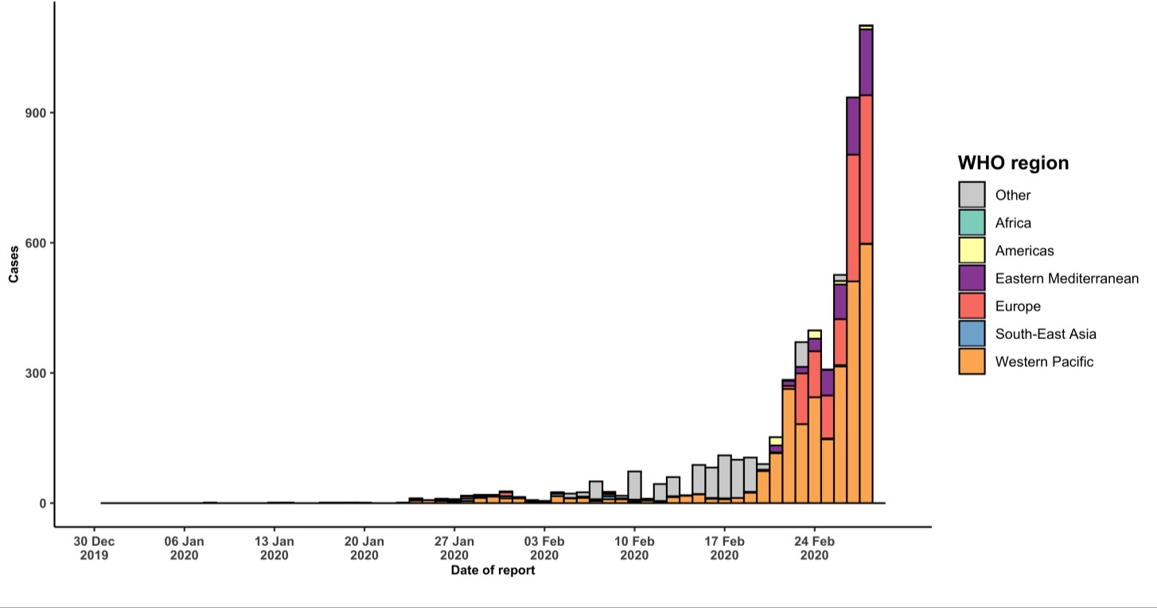
STRATEGIC OBJECTIVES

WHO’s strategic objectives for this response are to:

  - Interrupt human-to-human transmission including reducing secondary infections among close contacts and health care workers, preventing transmission amplification events, and preventing further international spread*;
  - Identify, isolate and care for patients early, including providing optimized care for infected patients;
  - Identify and reduce transmission from the animal source;
  - Address crucial unknowns regarding clinical severity, extent of transmission and infection, treatment options, and accelerate the development of diagnostics, therapeutics and vaccines;
  - Communicate critical risk and event information to all communities and counter misinformation;
  - Minimize social and economic impact through multisectoral partnerships.

*This can be achieved through a combination of public health measures, such as rapid identification, diagnosis and management of the cases, identification and follow up of the contacts, infection prevention and control in health care settings, implementation of health measures for travelers, awareness-raising in the population and risk communication.

PREPAREDNESS AND RESPONSE

- To view all technical guidance documents regarding COVID-19, please go to this webpage.
- WHO is working closely with International Air Transport Association (IATA) and have jointly developed a guidance document to provide advice to cabin crew and airport workers, based on country queries. The guidance can be found on the IATA webpage.
- WHO has been in regular and direct contact with Member States where cases have been reported. WHO is also informing other countries about the situation and providing support as requested.
- WHO has developed interim guidance for laboratory diagnosis, advice on the use of masks during home care and in health care settings in the context of the novel coronavirus (2019-nCoV) outbreak, clinical management, infection prevention and control in health care settings, home care for patients with suspected novel coronavirus, risk communication and community engagement and Global Surveillance for human infection with novel coronavirus (2019-nCoV).
- WHO is working with its networks of researchers and other experts to coordinate global work on surveillance, epidemiology, modelling, diagnostics, clinical care and treatment, and other ways to identify, manage the disease and interrupt onward transmission. WHO has issued interim guidance for countries, which are updated regularly.
- WHO is working with global expert networks and partnerships for laboratory, infection prevention and control, clinical management and mathematical modelling.
- WHO has prepared a disease commodity package that includes an essential list of biomedical equipment, medicines and supplies necessary to care for patients with 2019-nCoV.
- WHO has provided recommendations to reduce risk of transmission from animals to humans.
- WHO has published an updated advice for international traffic in relation to the outbreak of the novel coronavirus 2019-nCoV.
- WHO has activated the R&D blueprint to accelerate diagnostics, vaccines, and therapeutics.
- WHO has developed online courses on the following topics: A general introduction to emerging respiratory viruses, including novel coronaviruses (available in French, Chinese, Spanish, and Portuguese); Critical Care of Severe Acute Respiratory Infections; and Health and safety briefing for respiratory diseases - ePROTECT
(available in French); Infection Prevention and Control for Novel Coronavirus (COVID-19); Critical Care Severe Acute Respiratory Infection
- WHO is providing guidance on early investigations, which are critical to carry out early in an outbreak of a new virus. The data collected from the protocols can be used to refine recommendations for surveillance and case definitions, to characterize the key epidemiological transmission features of COVID-19, help understand spread, severity, spectrum of disease, impact on the community and to inform operational models for implementation of countermeasures such as case isolation, contact tracing and isolation. Several protocols are available here: https://www.who.int/emergencies/diseases/novel-coronavirus-2019/technical-guidance/early-investigations One such protocol is for the investigation of early COVID-19 cases and contacts (the “First Few X (FFX) Cases and contact investigation protocol for 2019-novel coronavirus (2019-nCoV) infection”). The protocol is designed to gain an early understanding of the key clinical, epidemiological and virological characteristics of the first cases of COVID-19 infection detected in any individual country, to inform the development and updating of public health guidance to manage cases and reduce the potential spread and impact of infection.

RECOMMENDATIONS AND ADVICE FOR THE PUBLIC

If you are not in an area where COVID-19 is spreading, or have not travelled from an area where COVID-19 is spreading, or have not been in contact with an infected patient, your risk of infection is low. It is understandable that you may feel anxious about the outbreak. It’s a good idea to get the facts from reliable sources to help you accurately determine your risks so that you can take reasonable precautions (See Frequently Asked Questions). Seek guidance from WHO, your healthcare provider, your national public health authority or your employer for accurate information on COVID-19 and whether COVID-19 is circulating where you live. It is important to be informed of the situation and take appropriate measures to protect yourself and your family (see Protection measures for everyone).

If you are in an area where there are cases of COVID-19 you need to take the risk of infection seriously. Follow the advice of WHO and guidance issued by national and local health authorities. For most people, COVID-19 infection will cause mild illness however, it can make some people very ill and in some people, it can be fatal. Older people, and those with pre-existing medical conditions (such as cardiovascular disease, chronic respiratory disease or diabetes) are at risk for severe disease (See Protection measures for persons who are in or have recently visited (past 14 days) areas where COVID-19 is spreading).

